Belt Failure Analysis

I have had two similar belt failures. The first happened while during a 'full' power run up. The next broke on its third flight at about 51 kW (battery power) approx 1 minute after full power application. On its previous flight it had experienced 1.5 minutes at 51 kW around 4000 to 4500 rpm. On its first flight it was running at full torque at 3000 rpm from 5 to 10 minutes.
In both belt failures the toothed inner layer separated from the outer, carbon reinforced layer. For the ground failure, some of the toothed layer remained attached. Large strips of it had peeled away from the outer layer. Both belts were Gates 12mm polychain carbon belts (8MGT-640-12).

Failure Modes
The belt consists of an inner toothed layer of polyurethane (PU) with an outer layer reinforced by carbon fiber. There is an addition surface of blue nylon o he teeth to reduce contact friction of the teeth. The nylon surface had no bearing on the belt failure.
Severe impact loads cause tooth breakage. This is a common failure on motorcycles where the wheel becomes airborne, speeds up because it is unloaded, then hits the ground suddenly again. My belt failures were unlike this scenario.
Loose tension will cause the belt to ride out closer to the tips of the teeth. This results in force on the teeth being applied more towards their tips of the teeth, creating a bending moment trying to separate the teeth from the base. Failure occurs when the toothed layer peels off as a strip from the outer, stiffer layer.
These two failure modes are well documented. Mine was neither.
I found nothing in the literature covering longer term, non impact, overload situations. But there is much knowledge on the behavior of polyurethane (PU) under load. When overloaded PU will creep and not completely return to its original form when the load is removed. This effect will be cumulative. Subsequent overloading will add more creep.
The outer, carbon reinforced, later is much stiffer than the PU layer. The creep will try to make the PU layer longer. The only way that can happen next to the stiffer outer layer is if the inner layer buckles and folds inwards. It will peel away at the joint between the PU and the outer layer. The result should resemble a loose tension failure.
That is what I believe happened here. One reason I do not think the belts were under tensioned is that when too loose, the driver sprocket will ratchet over the teeth. No ratchet sound was heard.

Figures 1 and 2 are profile views of each failed belt. They both exhibit the missing toothed layer. Figure 3 show a face view of inside the belt showing with the carbon fibers in the outer layer.

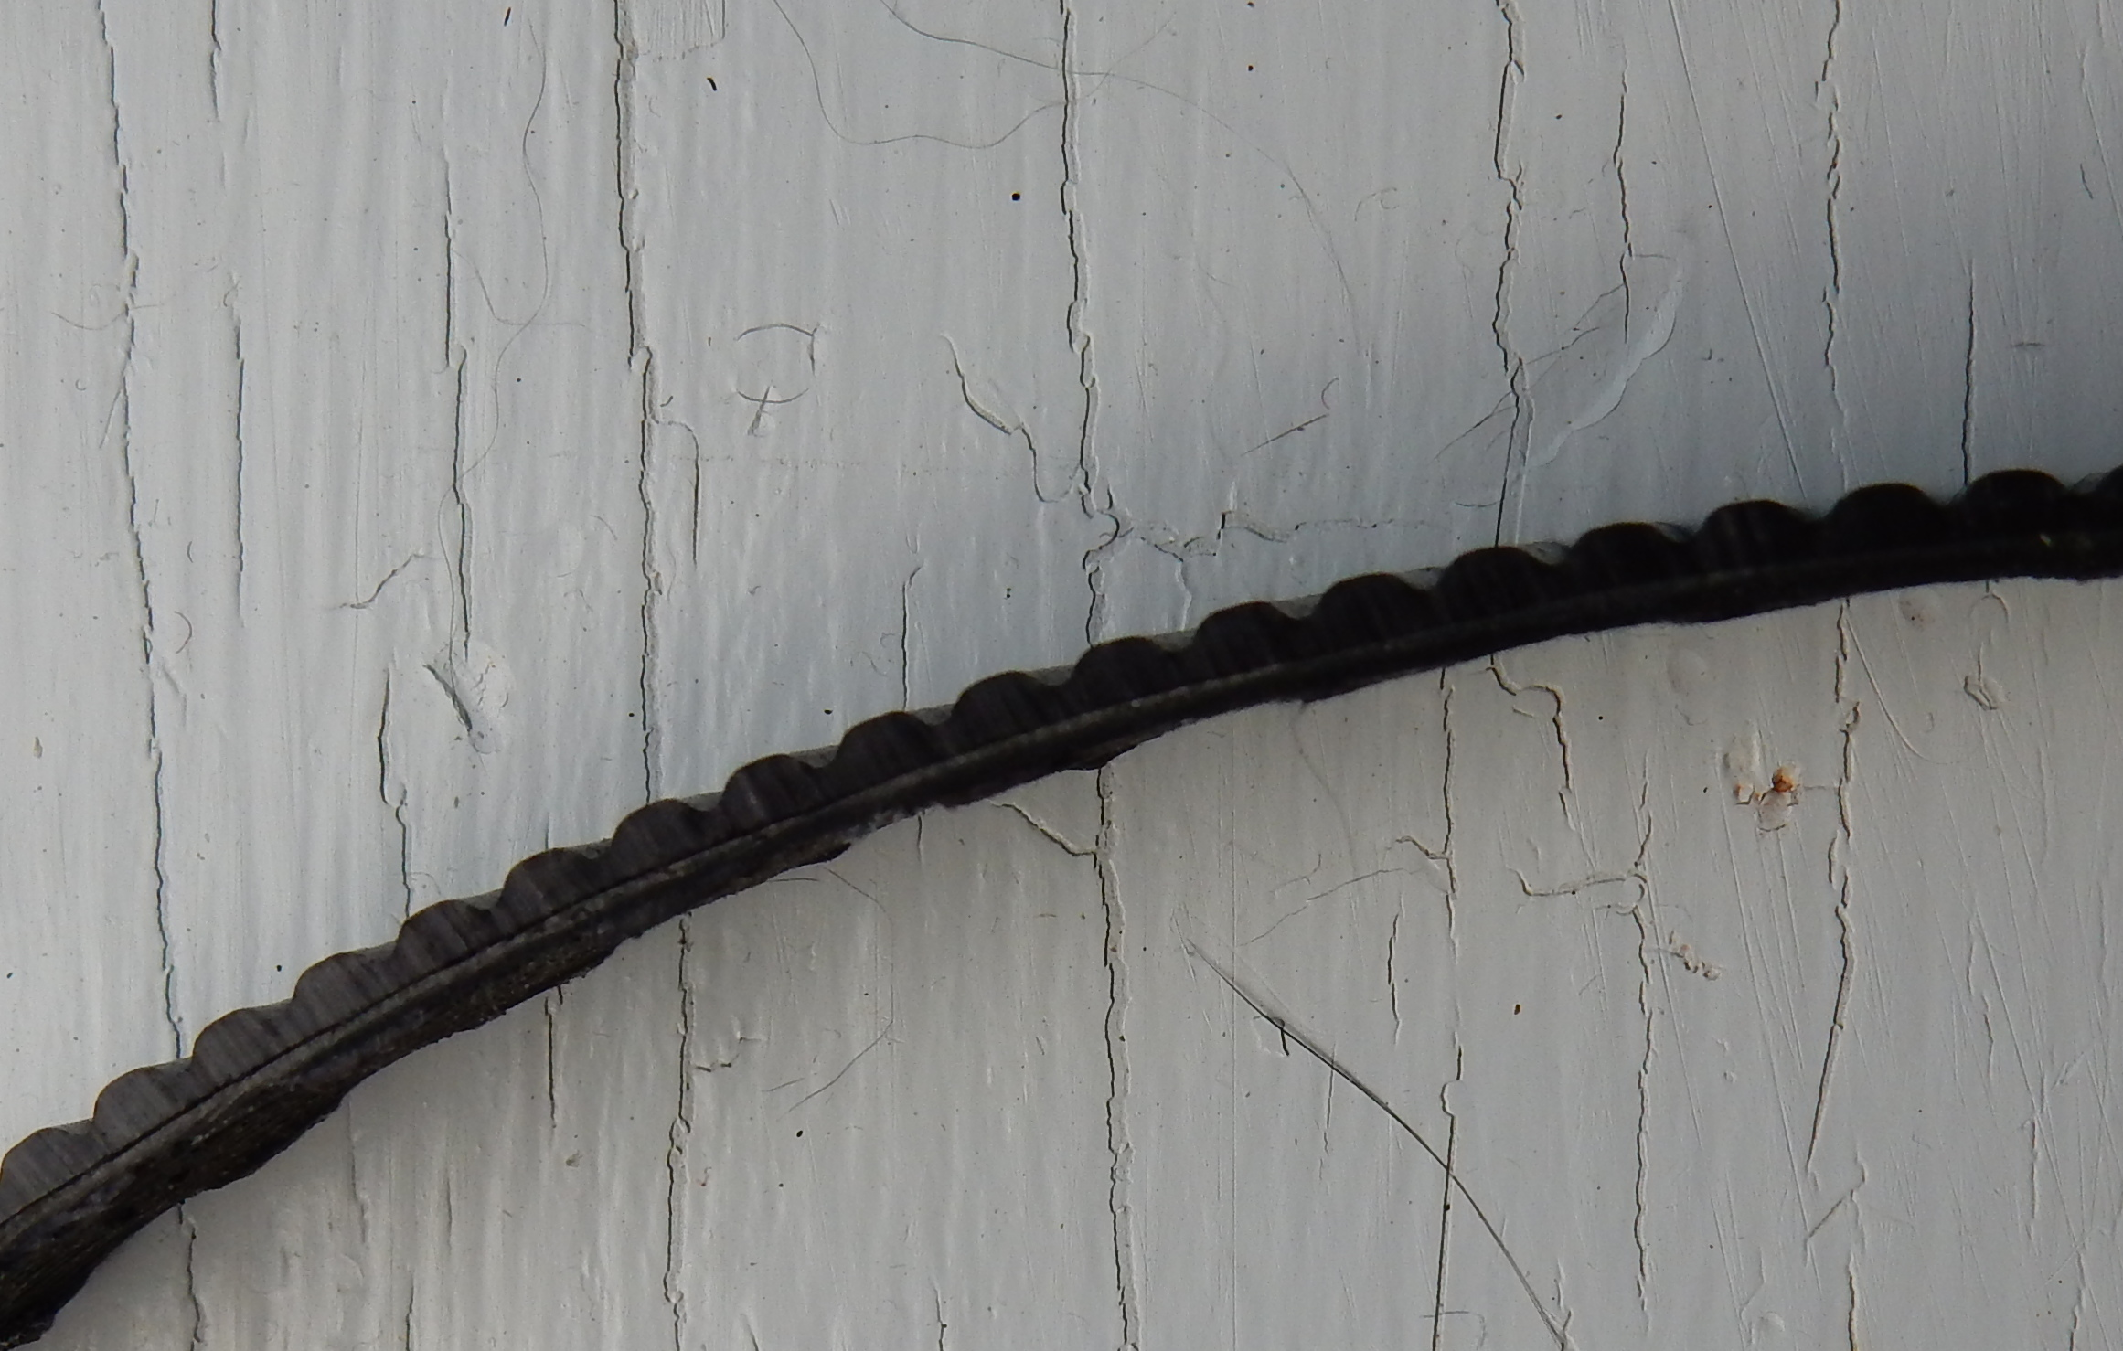Figure 1: Belt A profile missing inner, toothed layer
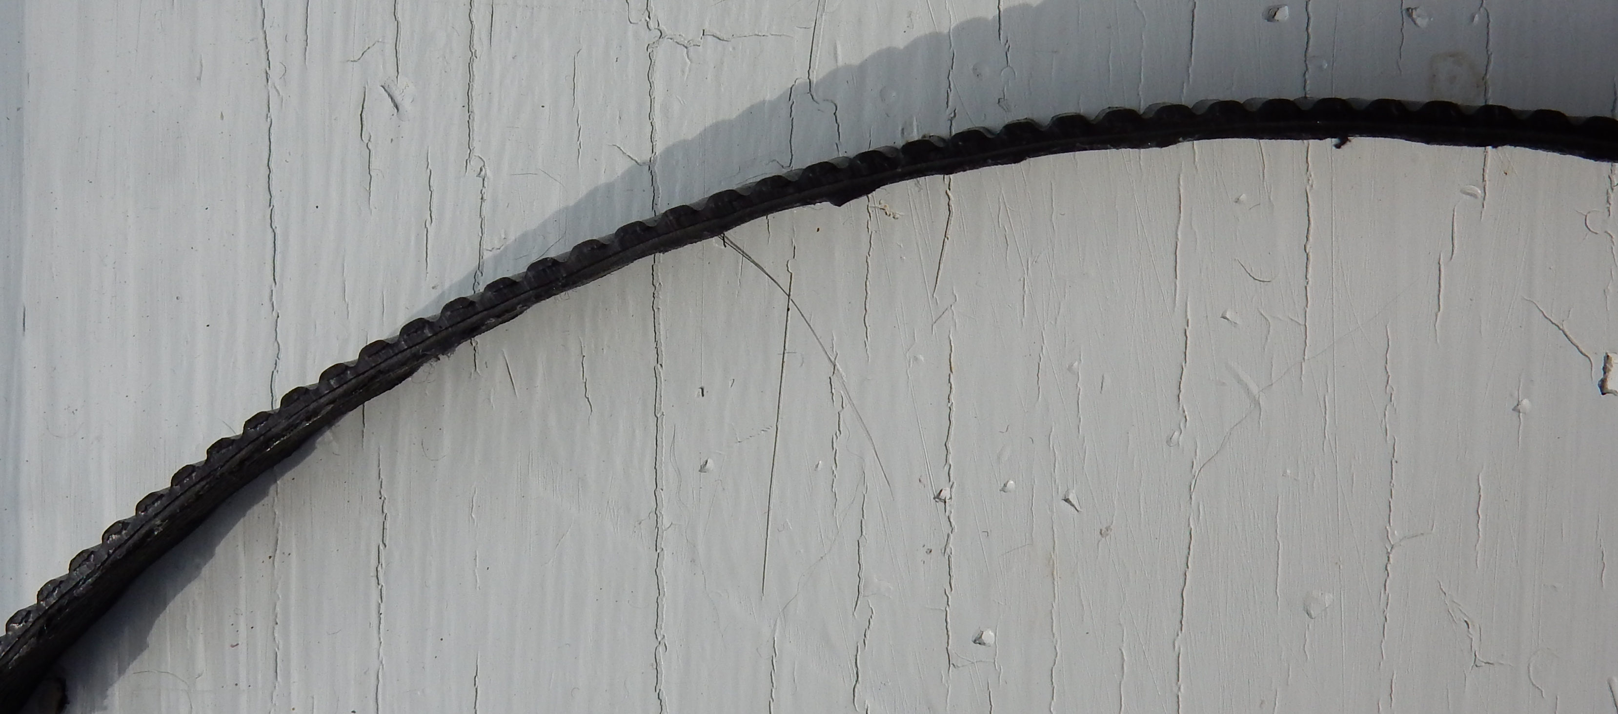Figure 2: Belt B profile missing inner, toothed layer

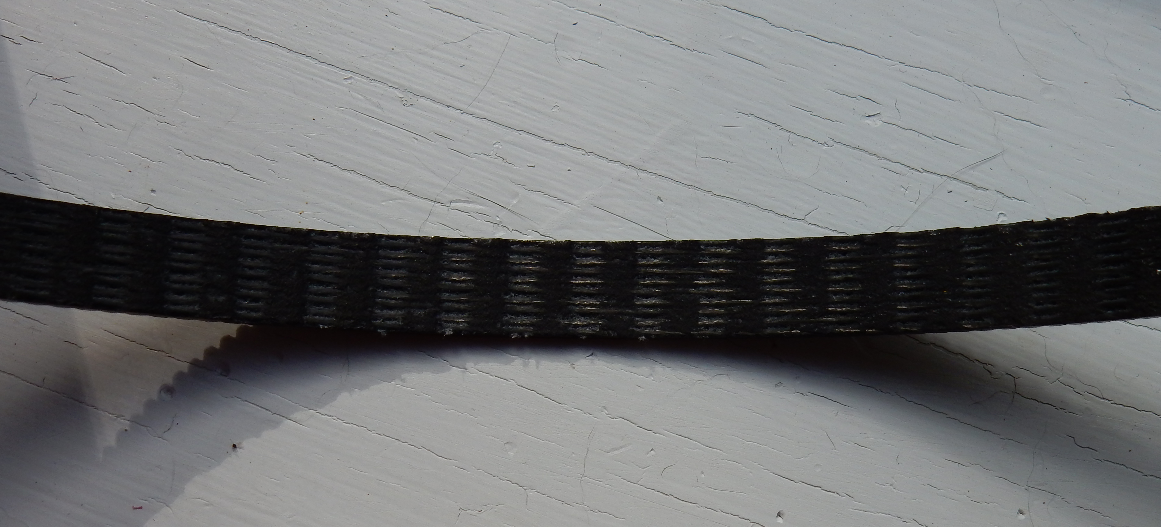Figure 3: Inner face of stripped belt

Belt Loading
From Gates polychaingtcarbondrivedesignmanual.pdf, here is a relevant page. The column for the 28 tooth driver sprocket used is highlighted. As expected, the column shows that power rating increases with rpm. Note that these ratings are intended to be reduced depending on the severity and frequency of load variations. Ordinary aircraft propeller operation is smooth. Regen adds backward loading on belts interrupting that smoothness to some extent.

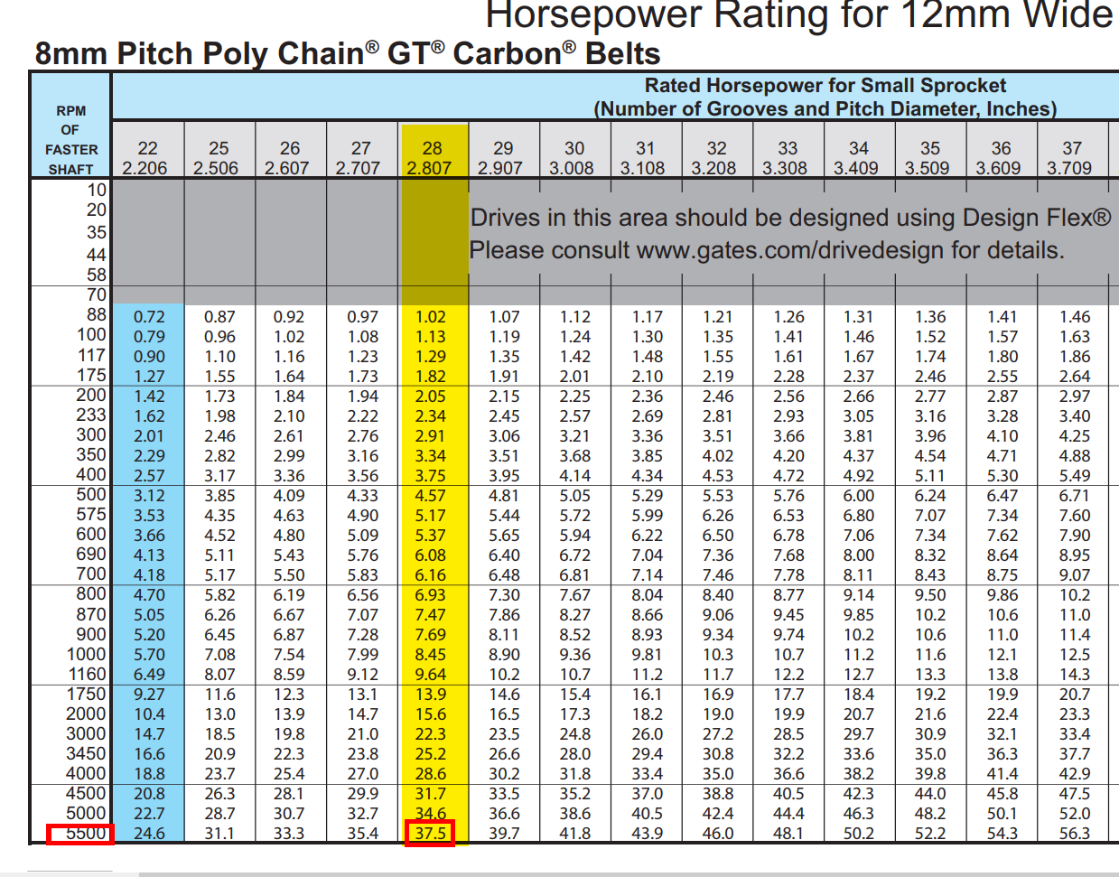Figure 4: Belt rated power

Since my belts are 12 mm, the highlighted column is appropriate for my application. The highest power rating occurs at the highest speed of 5500 rpm. Since Zero motor power peaks around this speed (5600?) that is a good one to use. The 37.5 hp is the power output from the motor. Battery power would be larger to account for losses in the powertrain. The bulk of losses will be on the controller and the motor. Assume 95% efficiency for the controller and 90% for the motor. (Although the motor is probably a little less efficient, that would leave less power on the belt, which is safer). So the corresponding design battery power will be 37.5/(0.95*0.90)= 43.86 hp or 32.7 kW.
The battery power sent to motor was recorded as 51 kW (68.4 hp) at 4300 rpm when it failed. Accounting for powertrain losses, power at the motor would be (68.4*0.95*0.90=) 58.5 hp. Interpolating the rated power at 4000 and 4500 rpm, gives 30.5 hp. So the belt was operating at (58/5/30.5*100=) 192% rated.

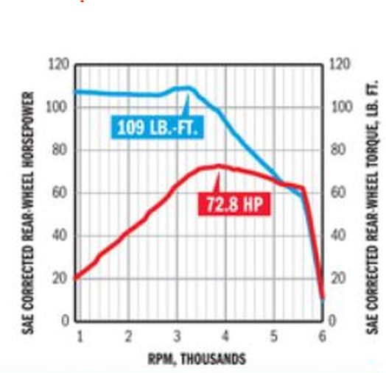Figure 1: Torque/power vs Speed
Figure 5 shows the performance curve for a Zero motor published in Motorcycle Consumer News.
On the flight when it was at peak torque for perhaps 10 minutes at 3000 rpm, from Figure 5, the power would have been around 60 hp. From Figure 4, the power rating for this speed is 22.3. So the belt was operating at (60/22.3*100=) 269% rated.
Just these two flights stressed the belt well beyond its rated capabilities. I believe that accumulated creep led to its ultimate catastrophic failure.
The correct belt width is 14 mm. the Gates design document shows the power rating is directly proportional to its width. So for those two overloaded flight cases, the belt would have been operating at 175% and 245% respectively.
For the future, I will operate within the rated capacity of the belts. I have put on a spare belt (12 mm) and am setting the prop pitch so that at 5500 rpm, battery power will be less than the 32.7 kW determined above. Custom mode will be set so its full throttle will be at this point. Regeneration will not be used. When a 14 mm belt is installed, with its 16% greater base rating, I will enable regeneration while maintaining those custom mode settings.

Other Reports
Why have there been no reports of similar belt failures in eGulls. I suspect it is because no one else has run as long at these higher power levels. Part of it is that the higher power settings drain the limited battery energy even faster. The other reason is that other motors have tended to overheat sooner, limiting the time that it is possible to stay at these power levels. My cowling has some mods designed to maximize cooling of the motor. Since I was able to spend around ten minutes under maximum load at 3000 rpm, apparently the mods worked. It would be easy for others to make similar changes and get similar results. It would be unfortunate if after someone else improved their motor cooling, they suffered the unintended side effect of a broken belt.

Zero Belt Design
It is difficult for me to imagine why Zero originally chose the belt design they did. Perhaps an unintentional error was made. Don't know. Even for the original 44 hp motor of the 2013 model when this belt was first used, it was underrated by Gates normal belt design methods. Why was this not a disaster? The Gates design is intended for commercial applications where premature failures would lead to unplanned downtime and expense. For a motorcycle, an unexpected breakage is usually just an annoyance. Anyone prone to breaking a belt would be more likely to do it from an impact load involving getting the wheels off the ground. Belt breakages have been relatively common. Some have switched to chain drives because of them.
On the other hand, when Zero redesigned the belt drive in 2017, with its thicker tooth design and a wider belt, is now more robust. Its base rating is higher than the motor power.
Although it might make sense to use the revised Zero belt powertrain as a basis for other applications, I would not recommend using the original Zero belt unless the motor is derated accordingly.
When I first considered building an eGull, I considered belt failures. I reasoned that belt failure would occur at the time of maximum stress, either when full power was first applied when starting the initial roll or when regen was applied during landing. In the first case I could just roll to stop on the runway. in the second case, since I was using regen, there was excess height so would just land a little further down the runway.
I was wrong. Failure from accumulated creep can happen any time higher power was being used... whenever and wherever the accumulated creep became unsustainable.

Conclusions
I will be operating to stay within the ratings specified by the published Gates design documentation. If you have other documentation that indicates different, e.g. higher, power ratings can be safely used, I would love to see it and adopt it.
Although maximum achievable climb rates will be reduced, overall operation effect will be minimal since, because of limited battery energy, most operations will be around 10 kW or less to extract the most range out of the system.
Although some of the details of my analysis might need changes, I believe the overall analysis and its general conclusions are valid.
Please examine and share this report with anyone else to get their assessment of validity and to seek improvements.

--Ray St-Laurent

